Swirl: Getting and Cleaning Data

Practica 1: Manipulating Data with dplyr

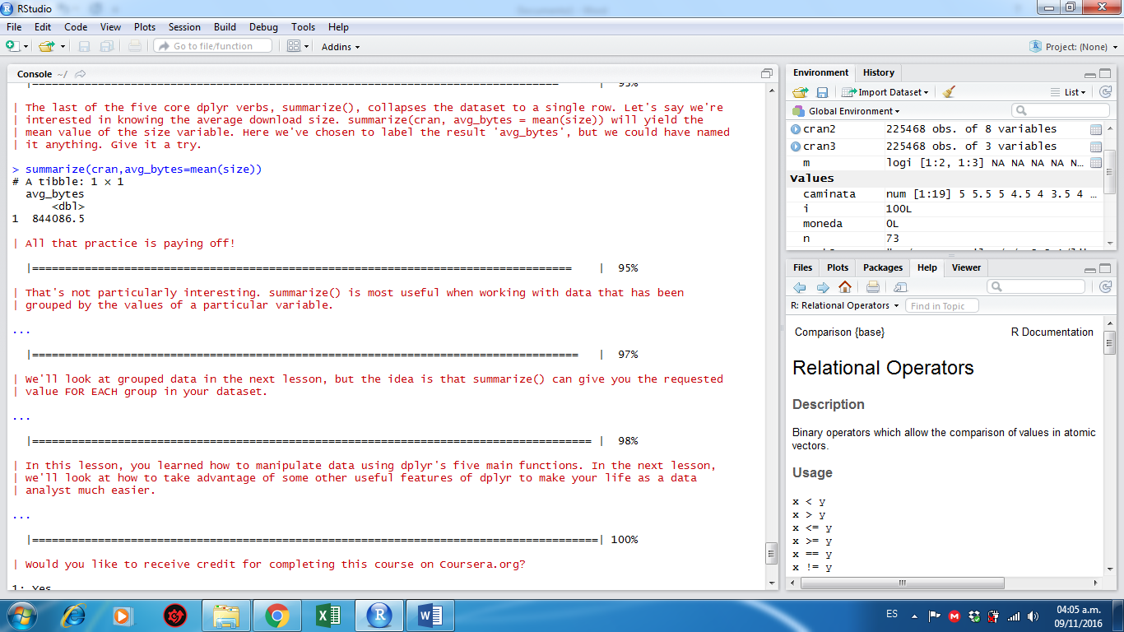

Practica 2: Grouping and Chaining with dplyr

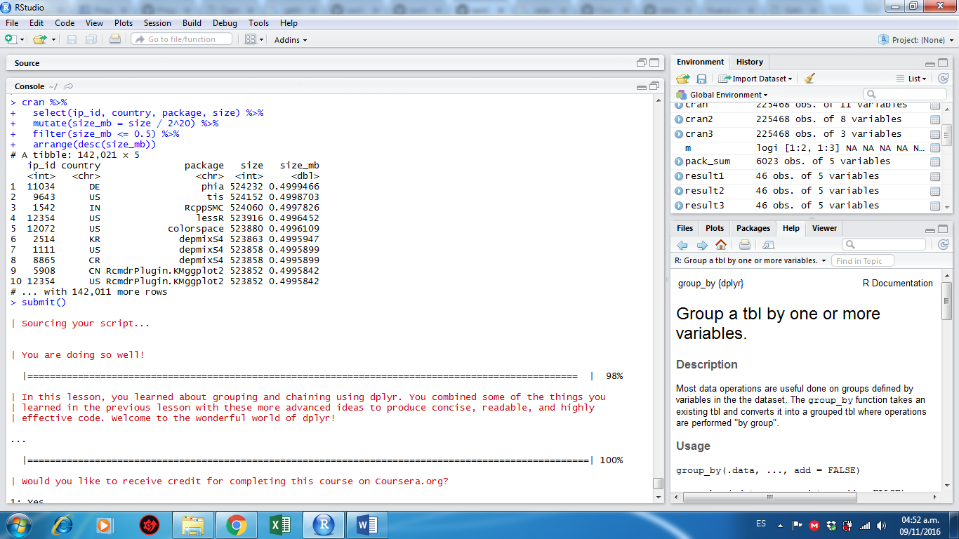

Practica 3: Tidying Data with tidyr

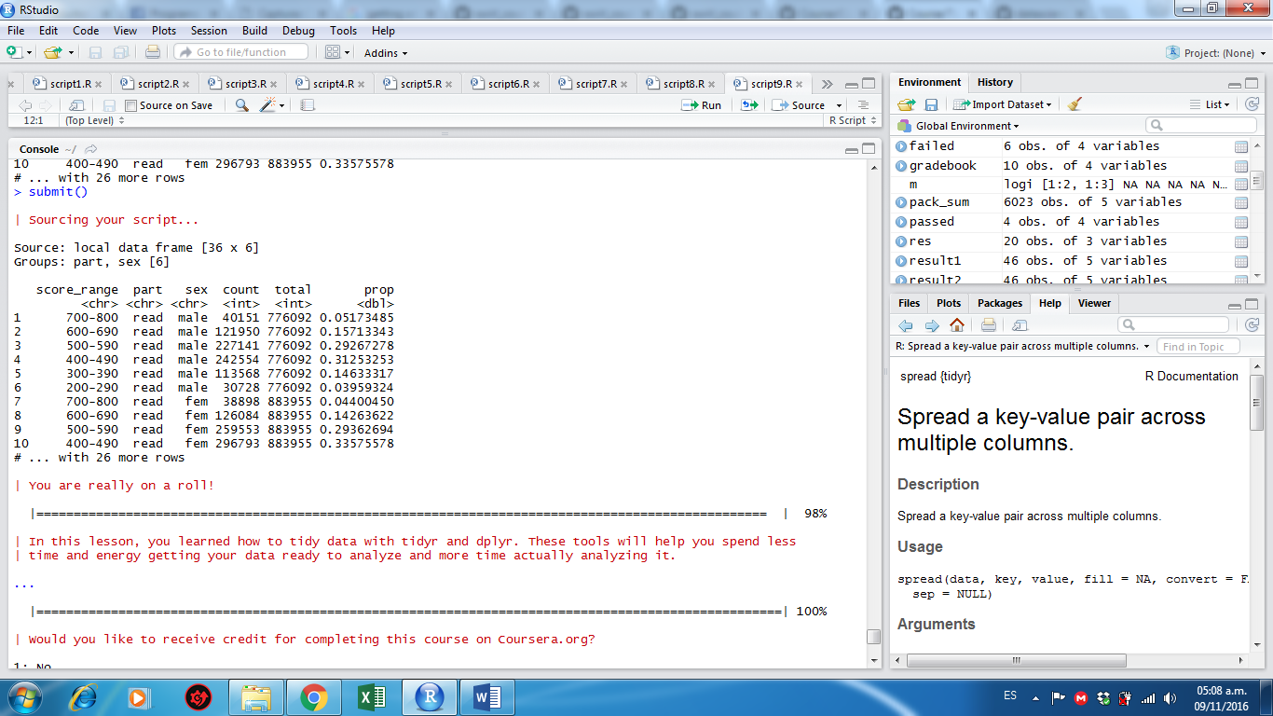

Practica 4: Dates and Times with lubridate

